WordPress Deployment on AWS EC2

STEP 1 — Launch EC2 Instance:
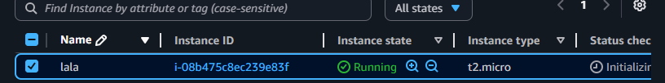
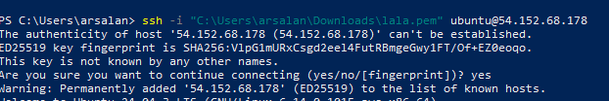
STEP 2 — Connect via SSH:
STEP 3 — Update EC2:
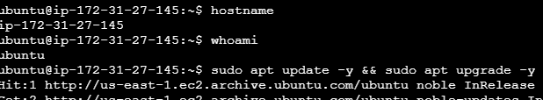
STEP 4 — Install Apache:

Open browser →:
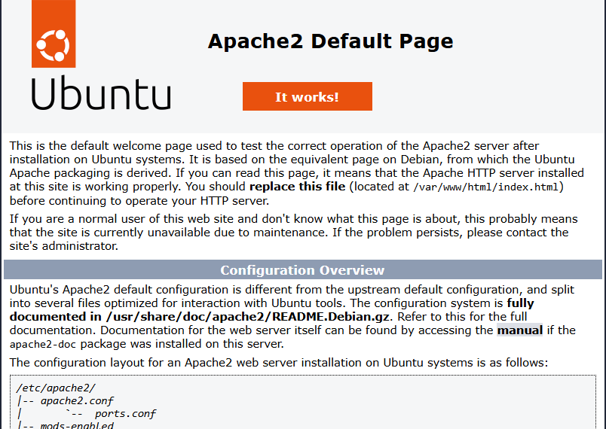
STEP 5 — Install PHP:
STEP 6 — Install MariaDB:
Secure it:
Press enter multiple times, choose Y/Y.

STEP 7 — Create WordPress DB:
Inside MySQL:
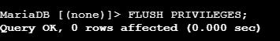
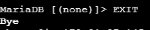
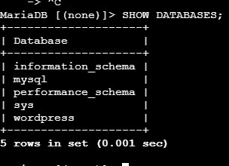
STEP 8 — Download WordPress:
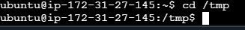
It Changes your current directory to /tmp, a temporary folder on your EC2 instance.
Downloads the latest WordPress package from the official website.

Extracts the downloaded .tar.gz archive. You’ll get a wordpress folder containing all WordPress files: PHP scripts, themes, etc.
Verify:
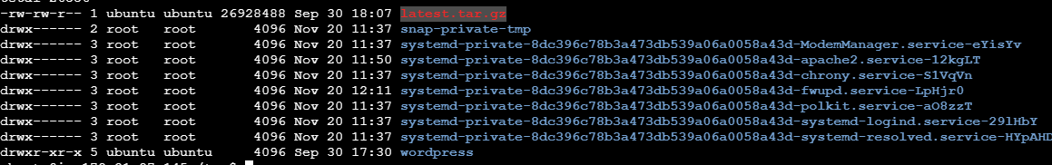
Move it to Apache directory:

Verify:
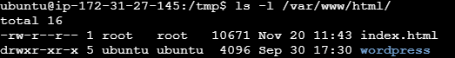
STEP 9 — Set Permissions:
Apache needs proper ownership and permissions to read/write files.
STEP 10 — Configure Apache Virtual Host:

Its open editor file and write that on editor:
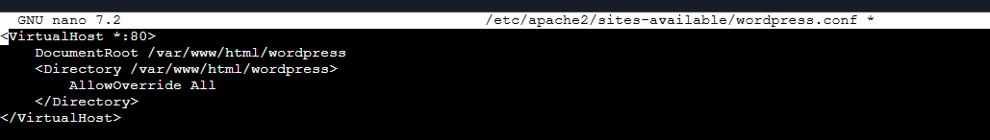
After saving that comes out from editor, enable these:
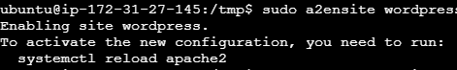
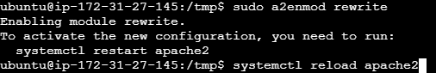
Then reload and restart the apache2:

STEP 11 — Final Step:
Finally go to browser paste your public IP: 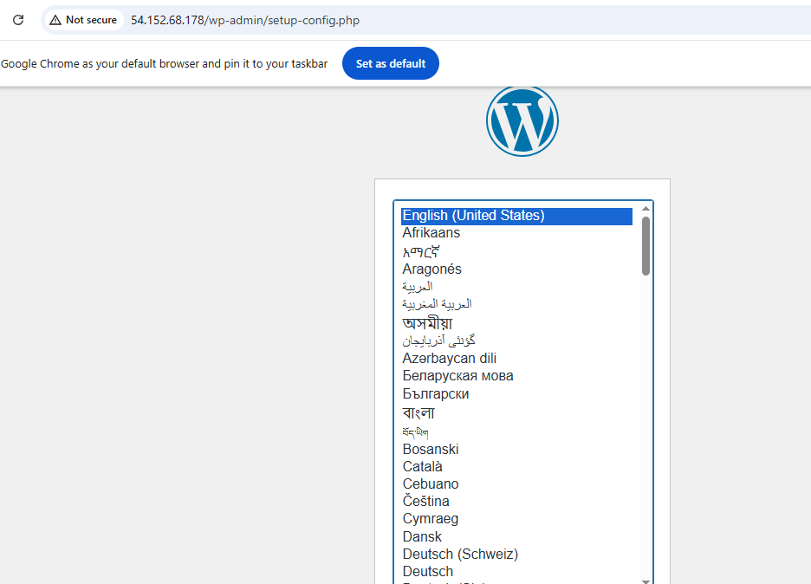

Note: if your browser showing again apache site then do this step:
- Remove the default page:
- Optionally move WordPress to root (/var/www/html/) so it becomes your main site:
- Fix permissions so Apache can read/write files:
Then visit browser again, its show Wordpress setup page.

